Membership Application

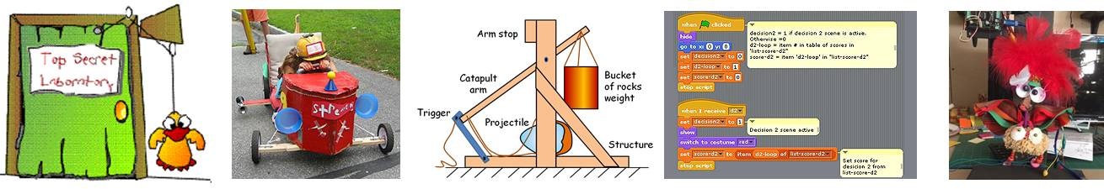

Builders age 8 – 18 … We want you!
Join the Build-It-Yourself crew of builders and evolve your passion for art and engineering. Build with art and engineering students from well-known schools, including MIT, Cornell, Mass Art, and Harvard.

Goals:
- Develop a portfolio of projects demonstrating fluency in art, engineering, and technology.
- Think creatively.
- Exercise problem-solving techniques.
- Present ideas clearly, concisely, and convincingly.

Level Up Programs:
Single Project | Member | Intern
Eight 50-minute workshops | Forty 50-minute workshops | Forty 50-minute workshops
Up to 12 builders/group | Up to 12 builders/group | Up to 4 builders/group
8-12 years | 8-12 years | 13-18 years
Led by art and engineering students from well-known schools. | Led by art and engineering students from well-known schools. |  | Led by art and engineering students from well-known schools.
Select from 30 scheduled, standard BIY projects. The goal is to spark a passion for art, technology, and building | Members select from 30 scheduled, standard BIY projects. The goal is to evolve a passion for art, technology, and building. | Elite Builders will teach, join BIY product development teams and present BIY projects at conferences. The goal is to develop a portfolio of projects and experiences to help interns get into the colleges of their choice.
$100 | $400/year | $2,500/year

Application (Ages 8 - 18):
Please send an email to support@build-it-yourself.com with the following information:

- Intern Name
__________________________________________________________

- Birth Date
__________________________________________________________

- Parent Names
__________________________________________________________

- Telephone numbers
__________________________________________________________

- Address
__________________________________________________________

- Email address
__________________________________________________________

- List 3 skills you want to develop.
__________________________________________________________

- Describe your favorite hobbies and projects.
__________________________________________________________
__________________________________________________________
__________________________________________________________

Please copy or take a picture of this page and send it to:
Info@build-it-yourself.com

Time Commitment:
Members meet in our Webcast room for one hour weekly on Saturdays, Sundays, or weekday evenings. On average, members may spend 2+ hours per week in BIY webcast meetings and on assignments.

The Culture
The Build-It-Yourself Laboratory is run like a college research lab.
- Builders must apply to join our programs.
- There is no homework. There are goals.
- There are no cookbooks. Builders are encouraged to learn basic tools and then apply these tools in creative ways to build unique solutions.
- There are no ‘teachers.’ There are project leaders and mentors.
- There are no rules providing you respect your teammates.

It should be expected that not all kids will thrive in this environment.
Member (8-12 Yrs)

Parts, Tools, Supplies, and Software:
PowerPoint (Google Slides, WPS, Keynote), Minecraft, Blender, Scratch, Glue Gun, scissors, ruler, tape, cardboard, colored printer paper, premium quality junk.

Projects:
Set up your Lab, Flying Machines, Chain Reaction Machines, Scratch Games 101-102, Minecraft 101-104, Animated Cartoons, Emojis 101-102, Mechanical Garden, Money Machines, Website Design, Time Machines, Experimental Theater, Scratch Voice Recognition, 3D Graphics, Digital Music 101-102,

Skills Exercised:
Communication Skills, Graphics, and PowerPoint Presentation Design
- Present ideas clearly, concisely, and convincingly.
- Learn pixel and vector drawing tools.
- Apply measures of effective, creative graphics.
- Create animated gifs.
- Design 3D graphics

Problem-Solving Skills
- Define the problem and the goals.
- Research.
- Work with a team.
- Break a solution into simple parts.
- Document.

Programming
- Storyboard a user interface.
- Exercise 5 program primitives.
- Modularize code.

Website Design
- Measure attributes of successful websites.
- Learn internet infrastructure and terminology.
- Design information architecture and efficient, intuitive navigation.
- Learn HTML and CSS.
- Follow professional file management guidelines.
- Learn computer hardware and software architecture.

Mechanical / Robot Design
- Integrate 5 simple machines.
- Test the physics of flight.
- Exercise modular construction.
- Build sensors.
- Build motion modules.
- Build structural modules.
- Program microcontrollers.
- Learn basic circuit design.

Intern (13-18 yrs)

Parts, Tools, Supplies, and Software:
PowerPoint (Google Slides, WPS, Keynote), Text Editor (HTML. CSS, JavaScript, MySQL, PHP), Blender 3D, Audacity, Gimp (Photoshop), Glue Gun, BIY Arduino Construction System ($100)

Projects:
Create a lab book, personal website, and multimedia advertisement. Join a BIY development team. Join the BIY TA team. Present BIY inventions at conferences.

Skill Exercised
Communication Skills, Graphics, and PowerPoint Presentation Design
- Present ideas clearly, concisely, and convincingly.
- Use pixel, vector, animation, audio, video, and 3D drawing tools.
- Apply measures of effective, creative graphics.
- Teach

Problem-Solving Skills
- Define the problem and the goals.
- Research.
- Work with a team.
- Break a solution into simple parts.
- Document
- 4D project management process.

Web site design
- Measure attributes of successful websites.
- Learn internet infrastructure and terminology.
- Design information architecture and efficient, intuitive navigation.
- Learn HTML and CSS.
- Learn JavaScript, MySQL, and PHP
- Follow professional file management guidelines.

Programming
- Storyboard a user interface.
- Exercise 5 program primitives.
- Modularize code.
- Learn computer hardware and software architecture.

Mechanical / Robot Design
- Exercise modular construction.
- Build sensors.
- Build motion modules.
- Build structural modules.
- Program microcontrollers.
- Learn basic circuit design.

