The Yahoo’s House

List price: $235,000

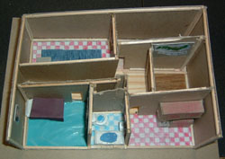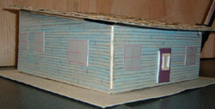

Lot size ½ an acre | Indoor basketball court
Softwood floors in living room and in Arcade | Seven rooms including Bedroom, Bathroom, Kitchen and living room
Indoor pool | Teak shingled shed roof
Central air conditioning | Oil heating
Foundation size 24’ x 34’ | Skylight above pool and basketball court

Property Overview:
A 24’ x 34’ Ranch with a shed roof. Vinyl siding with energy efficient Anderson windows. A newley shingled roof with teak shingles on a ½ acre of beautifuly-landscaped lot. There is a heated pool, and there is a brand new and energy efficient oil heating system. There is also a new central air conditioning system. A must see. The first $235,000 takes it, act quickly it won’t last long.

