House Construction Before / After Quiz

Imagine that you are given ½ acre of land in the woods and you must design and build a house you would want to live in. The foundation will be 24’x36’. You must build your house for under $150,000 in labor and materials (including your own time at market value) You must use computer tools including Power Point, Excel, Word and the Internet to help design, build and present your house.

- What is your strategy for planning the layout of your house?
  - Draw a perspective of your ideas and then start building a model.
  - List your requirements, test several rough layouts, then draw the layout to scale.
  - Call professional architects and builders.
  - No clue.

- What can you use Power Point for?
  - Presenting ideas and plans.
  - Researching important points.
  - Driving a nail into a stud.
  - Calculating a complex formula.

- On the Power Point screen below, mark ‘x’ on the icon that enables you to draw a multi-segment line.

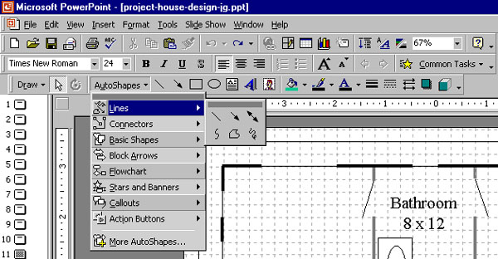

- What can you use Excel for?
  - Writing excellent memos.
  - Calculating expenses.
  - Drawing a floor plan.
  - Manipulating photos.

- Refer to the Excel screen below. To sum all expenses for framing, first click on the cell where you want to record the sum. Then click on the ______ icon in the menu bar. Finally drag your cursor from cell ________ to cell __________ and press the ENTER key.

- What is the Excel spread sheet formula for estimating the cost of joists in your floor?

- How would you create a column in your spread sheet to monitor your actual costs vs. your estimated costs?

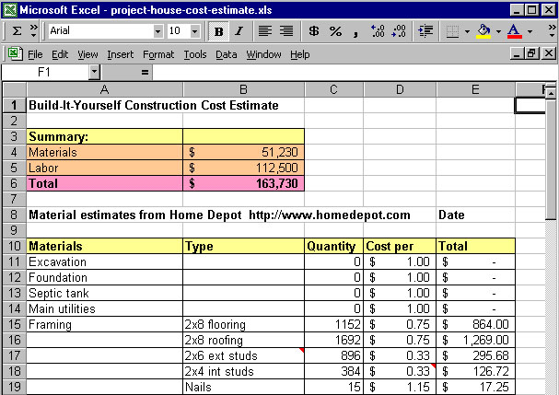

- Why is word better than Notepad or email for creating a property spec sheet?

- Refer to the Word screen below. Mark ‘X’ on the menu bar that enables you to insert a picture into Word document.

- Mark ‘O’ on the menu bar that enables you to add a table into the Word document.

- Mark “ +’s “ on the menu bar that enable you to change the font attributes.

- Mark “ #’s “ in the area where you can control indentation.

- How will you name your files?
- Power Point house design layout ______________________________

- Word property spec __________________________________

- Excel spread sheet expense estimate _____________________________

- Write a note for a friend that would enable him or her to find your files easily?

