

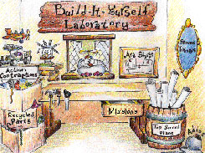

Build-It-Yourself has developed a playful, after-school enrichment program, driven by technology in education research at MIT, that teaches kids (8-18) to use technology constructively in a unique global laboratory. Our mission is to help the next generation of builders develop 21st century technology and problem solving skills. Recycled, everyday materials as well as state-of-the-art technologies are the means to the end: the creation of whimsical inventions.

Membership and Webcast Workshops

Build-It-Yourself
269 Pearl Street
Cambridge, MA 02139
Contact: Brent Scione, Liu Huan and John Galinato
Brent@build-it-yourself.com
LiuHuan@build-it-yourself.com
John@build-it-yourself.com

Membership includes:

- Four, live, 1-hour, Webcast workshops per month.
- Access to database of project plans and functional building blocks.
- Planet on Invention Universe, a social networking site for builders.
http://207.244.118.11/biy-iu/universe/client/InventionUniverse.html

Features and Benefits:

- Build-It-Yourself specialists primarily from the Cornell, Harvard, MIT, and Mass Art communities collaborate with students in a global laboratory via a state-of-the-art webcast platform. Students learn to communicate clearly and concisely using technologies that will be vital in their future.

- Each Build-It-Yourself project evolves from a storyline about a social issue and a challenge to use technology to solve or better understand that social issue. Students learn to apply technology for constructive ends.

- Build-It-Yourself content includes an online database of functional building blocks. These 'modules' enable students to build complex solutions relatively quickly.

- At Build-It-Yourself, the presentation of ideas is as important as the execution of ideas. Students must keep a PowerPoint lab book and must present their projects on the Web and in an exhibit. Students learn to sell their ideas and present concepts in a way that attracts attention.

- Build-It-Yourself projects are playful and incorporate a broad range of disciplines including art, technology, communication, and social science skills. Build-It-Yourself programs appeal to boys and girls, artists and builders, young and old.

Build-It-Yourself students have attended Harvard, MIT, Yale, Dartmouth, London School of Economics, Phillips Andover Academy, Harvard-Westlake School, Commonwealth School, Buckingham, Browne and Nichols School and Maggie L. Walker Governor's School.

A typical Webcast workshop:

Build-It-Yourself Webcast specialists will present a short 5-10 minute lesson or building technique followed by a 20-30 minute exercise. After the first exercise period, another 5-10 minute lesson is presented followed by a second exercise. During the exercise periods, members may collaborate with the Build-It-Yourself webcast specialists (2-way audio, 2-way video, and a white board.) Students present their progress and the webcast specialists answer questions and trouble shoot problems.

Requirements:

- Mac or Windows Computer with high speed Internet access, microphone, speakers and webcam.
- PowerPoint
- Depending on the project, freeware programs may be installed.
- Depending on the project, various tools and supplies may be purchased online.

Membership Tuition, Tools and Supplies:

MembershipTuition is $240 per year ($20 per month or $5 per 1-hour, live webcast)

Supplies for robotics programs vary depending on the project.

Tools and Supplies | Approximate Cost of Supplies
Software only projects | $ 0 (all software used is freeware)
Robotics projects | $ 250 (may be reused for several years)

Supplies may be coordinated with Build-It-Yourself and purchased.

Past and present instructors primarily from the Cornell, MIT, Harvard and Mass Art communities:

 | Liu Huan, Computer Science, MIT, 2010
 | Jamie Mckierman, Graphic Design, Massachusetts College of Art, 2009.
 | Jacob Bredthauer, Math and Computer Science, MIT, 2011.
 | Lindley Graham, Aeronautical Engineering, MIT, 2010
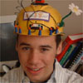 | Andrew Harlan, Mechanical Engineering, MIT, 2007
 | Aditi Dugar, Bio and Mechanical Engineering, Cornell, 2011.
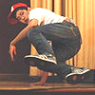 | Will Chou, Computer Science, Cornell, 2009
 | Pete Buletza, Computer Science, Harvard
 | Naseem Makiya, Philosophy and Film, Harvard, 2008

The following pages outline some of the Build-It-Yourself projects

Steam Punk Robots with an Attitude:
Sometimes we get so caught up in doing homework and acing tests that we don’t leave time to dream and play.

Project 1:
Build a band of computer-controlled, funky, ‘steam punk’ robots that act out a storyline. Imagine a strange herd of aliens who want to export their inventions to Earth, or a team of robots with super powers who foil the evil doers.

Construct a fantasy stage with exotic air ships and off-road-mobiles. Record sound effects and dialogue. Program a computer to make (or Remote control devices will make your) steam punk machines come to life and tell a story for the ages.

Project 2:
Many people take life too seriously. All work and no play. How
boooooooring! Our mission is to build a gal robot and a guy robot that can
teach humans how to dance, tell jokes, sing and celebrate the fruits of hard
work.

Invite your friends and family to a "Robots Rule Exhibit" at the end of the
semester. We’ll post the event on the Web for all to see.

http://www.build-it-yourself.com/biy-projects/proj-steam-punk-robots/index-steam-punk.html

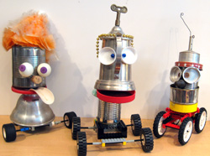

Remote Control Trucks that Navigate a Fantasy-land:
Messy "no-gooders" are mucking up our earth by creating mountains of garbage.

Your mission is to build a fleet of remote control vehicles to pick up, haul away and dump the mess. You will build a fantasy-land obstacle course and then steer your vehicle from the pickup site to the junk yard. You get to keep any candy and treasures you retrieve. One person's trash is another person's treasure!

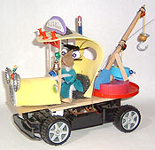 | 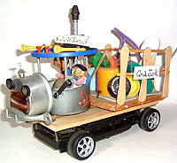
http://www.build-it-yourself.com/biy-projects/proj-trucks/index-trucks.html

Rube Goldberg Candy Machine:
Rube Goldberg was an inventor artist who dreamed of incredibly clever machines to solve very important problems. For example … the world needs more candy! Your mission is to build the ultimate candy delivery machine. A quarter will start the whole contraption. One team's link will hand off its load of candy to the next team's link and so on, until finally the candy is catapulted to the customer.

You can earn a ton of money and get terribly sick on all the candy you can eat!

Check out amazing Rube Goldberg machines in action on YouTube.
http://www.youtube.com/watch?v=L_wClO-nztI

There are LEGO and non-LEGO versions of this project.

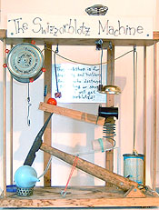

http://www.build-it-yourself.com/biy-projects/proj-rube-goldberg/index-chain.html

Remote Control Goblins:
Did your mom ever tell you not to play with your food? You'll need a good collection of funny-looking fruits and veggies, acorns, sea shells, craft supplies and premium quality junk. Then you'll need to dream up some jokes and cartoon story lines. Finally, you've got to make your critter come to life and act out your storyline using a remote control device!

Some builders have brought their remote control goblins along on Trick or Treat missions. An assistant goblin on Halloween means double the candy so you can get twice as sick!

http://www.build-it-yourself.com/biy-projects/proj-fruit-critters/index-critters.html

LEGO Robots That Earn Money:
Build-It-Yourself is looking for some hot shot inventors to fix the global economy.

Your mission is to build robots that create value, entertain, offer a service, put people to work, and pay its inventors handsomely. One young Build-It-Yourself engineer and his robotic sidekick earned $27.25 in one day.

Bill Gates ... the next generation of builders will soon be ready to carry your torch!



www.build-it-yourself.com/biy-projects/proj-money-makers/index-money-makers.html

Web Site Design Workshop:
Imagine that aliens from another planet are checking you out on the Web. Your mission is to design a Web site that will invite the aliens to be friends, complete with pictures, sound effects and video clips.

Your Web site must describe your favorite music, pets, heroes, jokes, sports and passions.

You will learn HTML code as well as the structure of a web site and the Internet.

The Build-It-Yourself Web Design Workshop will introduce you to tools that will make your Web sites jump off the screen and make your friends say, "Wow, how did you do that?"

http://www.build-it-yourself.com/biy-projects/proj-web-design/index-webpage.html

Computer Game Development Workshop:
(For students 9 - 18)
Want to make your own computer game? If you want to be a hot shot game designer, this is a good place to start.

Specify the game strategy and logic. (In the Build-It-Yourself world, violence and mayhem are outlawed.) Design graphics for friendly dragons, super heroes and other whacky characters. Lay out fantasy settings. Record outrageous sound effects. Integrate all the components. Test the game with your friends and then post it on the Web for the world to play.

We use Scratch, a programming language developed at the MIT Media Lab.

Check out Scratch projects others have built.
www.build-it-yourself.com/biy-projects/proj-scratch-games/index-scratch-games.html

Let the games begin!

http://www.build-it-yourself.com/biy-projects/proj-scratch-games/index-scratch-games.html

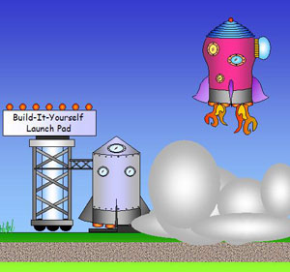

Soap Box Derby Workshop:
Join the hottest racing team on the block!

Build the best looking and fastest racer on the planet and then compete for fame and glory on the Build-It-Yourself Gran Prix Circuit.

You will build a race car from wood, boxes and parts from a hardware store. Paint and decorate your creation so it will attract attention. Then climb aboard and test your racing skills around an obstacle course.

You must be fast and you must look cool!

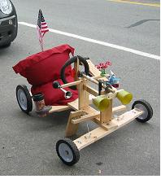

http://www.build-it-yourself.com/biy-projects/proj-soap-box/index-soap-box.html

Computer Graphics and Animation Workshop:
Civilizations are often measured by the art they leave for future generations. If we want to be recognized as a hot shot civilization, some of our art work and architecture needs help!

Your mission is to design digital artifacts, such as screen savers, Web pages, and illustrated storylines that will make future civilizations say, “Wow!” .

Learn from experienced designers & programmers how to design animated cartoons and far out graffiti, illustrate a storyline, and develop a Web site. You will learn to use both pixel and vector drawing tools.

www.build-it-yourself.com/biy-projects/proj-media-design/index-graphic-design.html

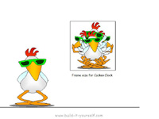

Digital Music Workshop:
Are you the next American Idol? Do you and your buddies like to dance, sing and make music?

Your mission is to use computer tools to:
1) Develop a rhythm.
2) Build lead riffs.
3) Write lyrics.
4) Create video clips.
5) Program or “mash” your resources.

This workshop is designed to help you be a music video director. Your video creation will be posted on the Web for the world to see. Amadeus and Hanna ... make way for the next super stars.

http://www.build-it-yourself.com/biy-projects/proj-digital-music/index-digital-music.html



Scratch Animation and Storytelling:
The age-old art of storytelling is an important measure of a civilization. Our storytelling needs to evolve in a way that reflects new technologies, social problems and human interests.

Your mission is to tell a story that reflects your dreams and fantasies. It could be a trailer for a computer game you would like to develop or an animated fairy tale that you would like to propose to Disney / Pixar.

You will learn to draw characters in PowerPoint and them put them in an interactive storyline using Scratch, a computer programming language developed at MIT.



http://www.build-it-yourself.com/biy-projects/proj-scratch-stories/index-scratch-stories.html

LEGO Sumo Robots
Who's the badest Sumo in the land?

Your challenge is to build a LEGO Sumo Robot that can bump all the other Sumo Robots out of the ring. Your robot must wrestle with honor and respect the traditions of Sumo culture.

You get points for strength, strategy, honor and good looks.

Bring it on! May the badest, toughest, fattest, smartest, best looking robots win!

http://www.build-it-yourself.com/biy-projects/proj-sumo/index-wkshp-biy-sumo-2004.html

Remote Control Pirate Ships
Pirates' Cove
Build-It-Yourself is recruiting a crew of scallywags and misfits to build a fleet of pirate ships that will search the seas for fat bankers who have too much money! "Avast ya bloody, nat brain, pigeon gut, lying weasel, double talking politician! Yer money or yer life."

Pirate ships will be powered by a remote control hull. Your mission is to navigate your pirate ships around a pirates' cove.

http://www.build-it-yourself.com/biy-projects/proj-pirates/index-pirate.html



The Mother of all Cuckoo Clocks (or Time Machines)
Do you have trouble waking up in the morning? Build a cuckoo alarm clock that starts the day in a civilized way. It could tickle you, play rock ‘n roll music, spray you with water, beat a drum, tell you a joke and more. Each hour your cuckoo clock will make a critter come to life.

A scratch program will keep time, play tunes, and drive motors that make your cuckoo critters shake, rattle and roll.

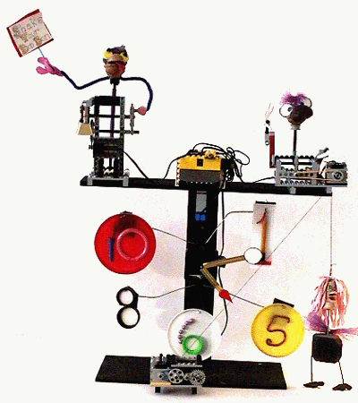

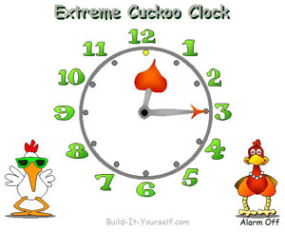

http://www.build-it-yourself.com/biy-projects/proj-clock/index.html

Flying Machines
We’re recruiting aspiring builders and designers to be part of an advanced aero-space development team. Your mission is to design and test a fleet of next-generation flying machines that will be tested for acrobatics, distance, speed and creativity.

Classes of flying machines include gliders, rubber-band driven planes, futuristic space ship designs and steam punk contraptions made from premium quality junk.

