Build-It-Yourself Project Overviews:

The next generation must solve extremely complex social, environmental and economic problems. We must prepare the next generation to be skilled at building and using technology constructively.

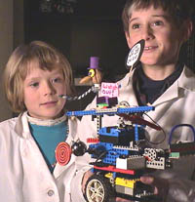 | 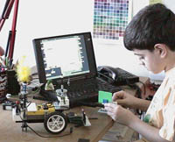
Build-It-Yourself is collaborating with the MIT Media Lab to develop a series of playful robotics projects and a library of construction tips that inspire and guide a broad range of boys and girls to build. Build-It-Yourself projects engage kids by showing them how to use technology to understand and solve important, relevant social issues.

- Build-It-Yourself Laboratory
- Creative Critters
- Junk Trucks
- Flying Machines
- Time Machines
- Music Makers
- Friendly Dragons
- Money Makers
- Mechanical Garden
- Pirates' Cove
- Animal Feeder
- Chain Reaction Machines
- Campaign for President of the Wild Things
- Bionic Boozer
- Game Machines
- Dream Houses

An overview of these projects is below.
- The social problem
- The mission
- Questions that students may contemplate.

Project #1 - Build-It-Yourself Laboratory

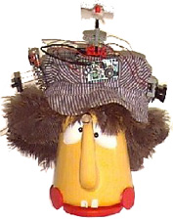 | The Problem:  The Build-It-Yourself Department of Important Inventions is looking for a few smart ladies and some hairy chested men to save the world from vile villains who build mean machines and scurrilous scoundrels who make a mess.  Our Mission:  If you want to be a Build-It-Yourself crew member, you must have a proper laboratory, a set of tools, parts, a big box full of high quality junk, a brainstorm hat, a lab jacket, a colorful shingle to let everyone know you're open for business, and a robot assistant at your door to greet friendly visitors.

Questions for discussion:
This project should put kids in a playful, creative state of mind. This project should set the stage for introducing teamwork guidelines, tool rules, presentation of ideas and the discipline required to solve tough problems.
- Who are your favorite 'builders' and why are they heroes?
- What qualities does it take to be a successful builder?
- Sharing ideas
- Presenting ideas
- Teamwork
- Discipline
- Initiative
- Creativity
- Focus on constructive goals
- Passion

- What is a robot?
- Does something useful.
- Has a degree of intelligence.
- What are examples of robots?
- Why do scientists and engineers keep lab books?

Project #2 - Creative Critters

 | The Problem:  Did your mom ever tell you not to play with your food? Food is only for eating.  Our Mission:  Our mission is to open minds to clever, creative ways of thinking and using materials. In the process we aim to make people laugh! You'll need a good collection of funny-looking fruits and vegetables, nuts, craft supplies and junk. Then you'll need to dream up some jokes and cartoon story lines. Finally, you've got to make your critter come to life and act out your storyline!  .

Questions for discussion:
Sometimes too many rules can keep us from thinking about exploring new and better ways to do things.
This project should inspire discussions about creativity and thinking outside the box.
- What inventors have broken traditional rules and thinking to build something that has changed the way we live?
- What are examples of things that were built for one application but ultimately worked for many applications? (The Internet, Aspirin, ???)
- What conditions stimulate creativity? (When do we get our best ideas?)

Project #3 - Junk Trucks

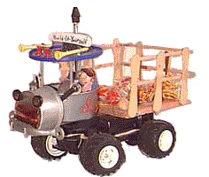 | The Problem:  Messy "no-gooders" are mucking up our earth by creating mountains of yucky garbage.  Mission:  Your mission is to build a fleet of trucks to help haul away the mess.

Questions for discussion:
This project should get kids thinking about the importance and value of recycling.
- How many garbage trucks will we need to collect all the garbage in 2010?
- What are the advantages of recycling?
- How much can be saved by recycling?

Project #4 - Mechanical Garden

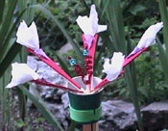 | The Problem:  Our good earth is getting fouled up 'cause too many people are throwing away their junk. We need to recycle our trash!  Mission:  The Build-It-Yourself crew is on an important mission to turn trash into treasure. Here's the deal ... collect a compost pile of Popsicle sticks, bottle caps, plastic spoons, ribbons and other good junk. Then grow a garden full of colorful, soulful, wild species ... exotic plants and animals never before seen. Make them move. Program them to interact.

Questions for discussion:
This project should help kids appreciate the importance of protecting the delicate balance of life.
- What have been some of the consequences of our pollution?
- Is it ever necessary to pollute?
- How can we minimize or control pollution?
- What are the advantages of recycling?
- How much can be saved by recycling?

Project #5 - Flying Machines

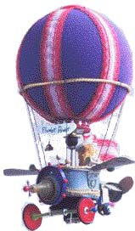 | The Problem:  Exploring new trails is a basis human need.  Mission:  Your mission is to build a model of a flying machine that could take you to a  favorite place like the planet Pluto or Cloud #13.  Questions for discussion:  - How have transportation inventions changed the way we live?  - For the better?  - For worse?  - How do you think the world would be different if we did not have inventions that enable us to travel long distances quickly?

Project #6 - Time Machines

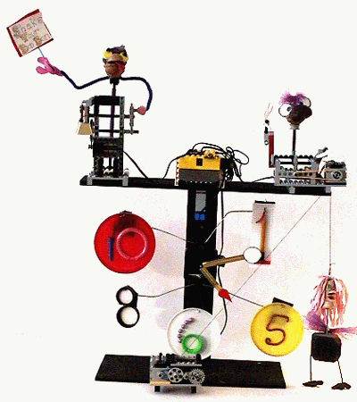 | The Problem:  Time is precious. Need an invention that will wake you up in the morning? Or a machine that tells you when it's play time, lunch time, time out, real time ...?  Mission:  Your mission is to build a machine that tells time and reminds us when its time to do important things.  Questions for discussion:  This project must help kids understand the importance of time.  - What are some provocative quotes, rhymes and poems about time?  - How much time do you waste during a day?  - When do you want to do things as quickly as possible and why?  - When do you want machines to do things as quickly as possible and why?  - Is keeping track of time ever not important?

Project #7 - Friendly Dragons

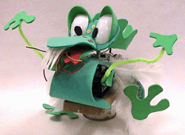 | The Problem:  The world is full of Prejudice. Judgments are often mistakenly made about people based on how they look or  where they come from. Imagine if you were a dragon and everyone was trying to slay you just because you looked like a dragon. Of course you'd be mean and fight to protect yourself.  If we want to live in a land free of meanness, this cycle of prejudice and counter-prejudice must be stopped.  Mission:  Your mission is to figure out what a dragon must do to win a friend. Then you must build and present that dragon. You must program your dragon to offer a friendly greeting when it detects another life form. The goal is to show that ... you can't judge a dragon by its scales!

Questions for discussion:
This project should help kids think about the consequences of prejudices.
- What's the definition of prejudice?
- What are examples of prejudices?
- What causes prejudices to form?
- What prejudices do you have?
- Why can prejudices be bad?
- Could prejudices ever be good?
- What can one do to eliminate a prejudice?
- What can the subject of a prejudice do to help eliminate a prejudice?

Project #8 - Money Makers

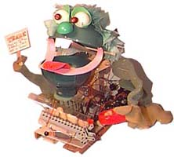 | The Problem:  The world economy is in shambles.  Doom and gloom is predicted.  Too many humans are looking for free rides.  Not enough people are building.  Mission:  Your mission is to hatch a herd of capitalist Wild Things that create value, set the world straight, and earn a fortune!

Questions for discussion:
This project should inspire discussion about rewards and the advantages and disadvantages or social systems vs. capitalistic systems.
- Should everyone get the same rewards regardless of how hard he or she works?
- What is the definition of a social economic system?
- What is the definition of a capitalistic economic system?
- What are the good and bad consequences of a social system?
- What are the good and bad consequences of a capitalistic system?

Project #9 - Campaign for President of the Wild Things

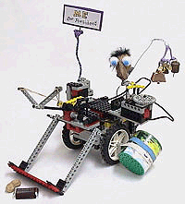 | The Problem:  Our politicians are mucking up the works. It's our duty to rescue the world from these nitwits!  Mission:  Our mission is to design, build and manage a non-human to run in a campaign for President of the Wild Things.  Questions for discussion:  - What are characteristics of a good leader?  - What characteristics appeals to voters?  - How should a candidate be judged?

Project #10 - Music Makers

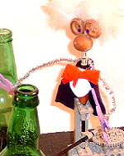 | The Problem:  Many people are mad, unhappy and in a funk about life and the world around them.  Mission:  Our mission is to build a band of hip hop robot music makers that can turn a frown into a smile.

Questions for discussion:
This project should kindle discussions about how music impacts our lives.
- Why is music so popular?
- How big is the music industry?
- How has music documented history and culture?
- What are some of the mathematical rules of music and sound?
- volume
- pitch
- tone
- octaves
- scales
- rhythms

Project #11 - Pirates' Cove

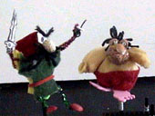 | The Problem:  The rich get richer and the poor get poorer.  Mission:  Your mission is to search the seas for fat bankers who have too much money. "Avast ya bloody, nat brain, pigeon gut, lying weasel, double talking politician! Yer money or yer life."
Questions for discussion:
This project should prompt discussions about what drives people to be pirates and robbers as well as the consequences of being a pirate. Sensible wealth distribution may also be an interesting topic.
- What was a pirate's life really like?
- Who were some of the most famous pirates and what did they do?
- How should wealth be distributed?
- Should a good soccer team be prevented from winning too much?
- Should everyone share rewards equally or should those who work the hardest get the most rewards?

Project #12 - Bionic Boozer

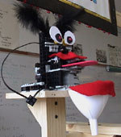 | The Problem:  Drinking alcohol irresponsibly can be dangerous and expensive.  Mission:  Your mission is to build a model of the circulatory, nervous and digestive systems and show how these systems react to various levels of alcohol consumption. The goal is to understand what happens in your body when the level of alcohol in your blood stream results in you being sober, happy or sick.

Questions for discussion:
- Why do your reflexes become slower when you are drunk?
- Why is drinking alcohol when one is pregnant bad?
- What is the cost to the public of drinking irresponsibly?
- How many people die or get seriously sick?
- How much productivity is lost because of irresponsible alcohol consumption?
- What is the cost to the public of treating alcoholics?
- When is one considered an alcoholic?
- How big is the liquor industry?
- What are the benefits of alcohol consumption?

Project #13 - Chain Reaction Machines

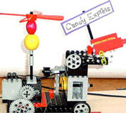 | The Problem:  "Globalization ... a nation of nations" sounds good but it hasn't been easy to get there. People in different parts of the world are not communicating, sharing ideas, or working together.  Mission:  Our mission is to build a team of machines that show the nitwits who call themselves 'humans' how to communicate and work together.  See an example of 5 chain reaction links that collaborate to deliver 'health food' across the land.

Questions for discussion:
This project should kindle discussions about the importance of teamwork, sharing ideas and communication.

Project #14 - Animal Feeder

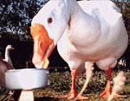 | The Problem:  Ever wonder what a skunk or raccoon looks like up close and personal when it's prowling for tasty chicken bones in your back yard garbage barrel in the middle of the night?  Mission:  Your mission is to build an animal feeding and observation station, record the habits of various animals and then make conclusions that will help us understand nature.

Questions for discussion:
This project should drive discussions about the value of understanding animal behavior.
- What is the value of a particular animal we want to study?
- What is the relationship between this animal and humans?
- What are the animal behaviors we want to study and why?
- How can we measure a particular animal behavior?

Project #15 – Game Machine

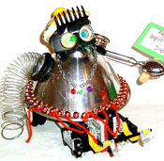 | The Problem:  Many important lessons in life are learned by playing games. Maybe we'd be a whole lot smarter if we had 'more-better' games.  Mission:  Your mission is to design and build games that teach us important lessons.  Who's the baddest in the land? This project is a game of strategy. It will test your ability to use leverage, friction, clever mechanisms, strong structures and complex programs. Rockem-Sockem-Saki!
Questions for discussion:
- What is the most important thing you have ever learned from reading a book?
- What is the most important thing you have ever learned from playing a game?

Project #16 - Dream Houses

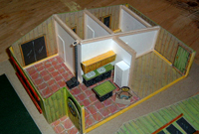 | The Problem:  Too often we live in places that are not inspiring or that do not kindle our unique interests.  Mission:  Your mission is to design a house that would be fun to live in ... that expresses your personality and inspires you to follow your dreams.

Questions for discussion:
- How much does your environment influence the way you think, your philosophy, your mood?
- How can a house change the way you live?

