Suggestions for Build-It-Yourself Promotion and Brochure Copy

Build-It-Yourself offers playful after-school workshops that inspire and empower students to invent. Our mission is to help the next generation of builders develop 21st century technology and problem solving skills.

Build-It-Yourself Goals for each student

- Be safe.
- Have fun.
- Get a constructive result.
- Inspire students to build on their own.

Build-It-Yourself Workshop Features and Benefits

- Build-It-Yourself specialists from Cornell, Harvard, MIT and around the world collaborate with students in a global laboratory via a state-of-the-art webcast platform. Students learn to communicate clearly and concisely using technologies that will be vital in their future.

- Each Build-It-Yourself project evolves from a storyline about a social issue and a challenge to use technology to solve or better understand that social issue. Students learn to apply technology for constructive ends.

- Build-It-Yourself content includes an online database of functional building blocks. These 'modules' enable students to build their own creative, complex solutions relatively quickly.

- At Build-It-Yourself, the presentation of ideas is as important as the execution of ideas. Students must keep a PowerPoint lab book and must present their projects on the Web and in an exhibit. Students learn to sell their ideas and present concepts in a way that attracts attention.

- Build-It-Yourself projects are playful and incorporate a broad range of disciplines including art, technology, communication, and social science skills. Build-It-Yourself programs appeal to boys and girls, artists and builders, young and old.

Instructors:

John Galinato is the founder and project leader at Build-It-Yourself in Cambridge, MA. After receiving a Master's degree in electrical engineering from Cornell, John worked on engineering teams to develop a submarine detection system, the lunar landing module, telemetry for a Venus fly-by, the Patriot missile system, computer graphics software and Web applications for more than 25 years.

Liu Huan, a partner at Build-It-Yourself, received his BS and MS in Computer Science / Robotics at MIT in 2011. Liu Huan is from Shanghai, China.

A team of specialists primarily from the Harvard, MIT, Cornell and Mass Art communities as well as former Build-It-Yourself students lead the workshops.

Past workshop leaders include:
- Aditi Dugar – BS Mechanical Engineering, Cornell
- Seth Mastin - BS Computer Science, MIT
- Valeria Roman - Science Journalist, Argentina
- Naseem Makiya – BA, Philosophy, Harvard
- Megan Firko - BS, Mechanical Engineering, MIT
- Hei Jung Kim - MEd, Harvard Graduate School of Education

Former Build-It-Yourself students have gone on to study at Harvard, MIT, Yale, Dartmouth, Brown, Choate and Phillips Andover.

Information about the staff and details of each week's project is posted at:
www.build-it-yourself.com

Brochure Copy that could be used for all Build-It-Yourself projects:

Students will enter a world where social science, art and technology merge in exciting ways.

or

Recycled, everyday materials as well as state-of-the-art technologies are the means to the end: the creation of whimsical inventions.

or

Build-It-Yourself students will have an opportunity to use state-of-the-art technology tools to collaborate and build in a unique, global laboratory.

or

Build-It-Yourself specialists from the Harvard and MIT community and from around the world will inspire and guide students on-site and via live Webcasts leading them toward an enriched understanding of the way things work.

Build-It-Yourself recommends adding this copy to promotion brochures:

[Please note: Build-It-Yourself workshops are rigorous. It is essential that students who enroll in a Build-It-Yourself program come eager to build and willing to work on teams of 2 or 3. Students must respect their teammates and their laboratory. Students must be prepared to focus intently on tasks such as drawing, documenting ideas in a lab book, using tools safely, building complex projects, programming computers and presenting their work. The "Law of the Lab" is strictly enforced.]

Mission Storylines, Components, Photos and Graphics

Suggested copy and graphics for your printed and web-based brochures follow. Storylines and mission descriptions are modular and can easily be cut and edited to fit your requirements.

You may use any of the provided photos / graphics. Some higher resolution graphics may be available on request.

Mission Index:
Contraptions and Robotics
- Set Up Your Laboratory
- Remote Control Trucks
- Puppets with an Attitude (LEGO version)
- Rube Goldberg Machines (LEGO version)
- Robots that Earn Money (LEGO version)
- Remote Control Pirate Ships
- Flying Machines
- Soap Box Racer
- Super Hero Robots (LEGO version)
- Remote Control Fruit Critter Goblins
- First LEGO League Coaching

Computer Programming
- 3D Graphics
- Website Design
- Computer Graphics and Animation
- Scratch Games
- Scratch Animated Cartoons
- Time Machines
- Digital Music Video
Remote Control Trucks

We’ve got a problem and we need your help. Messy blockheads are mucking up our Earth by creating mountains of garbage and tossing aside tons of premium quality junk.

You’ll need to come ready to create and build!

Your mission is to concoct and construct a fleet of remote control JUVs (Junk Utility Vehicles), along with their steadfast operators, to seek out, pick up, haul away and salvage the mess. You will build a fantasy-land obstacle course and then steer your vehicle from the pickup site to the junk yard. Since “one person's trash is another person's treasure,” you’ll also get to keep any candy and treasures you retrieve. Sweet!

This Mission includes:
Art | Construction | Modeling | Imagineering | Presentation | Trash Talking

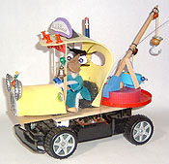 | 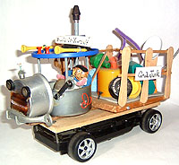
http://www.build-it-yourself.com/biy-projects/proj-trucks/index-trucks.html

Puppets with an Attitude

What’s up with all the doom and gloom these days? We all could use a bit of high-tech fun and entertainment. Join our production team and create, discover and hire a few Puppets with Attitudes to bring down the house!

You’ll design and build a band of computer-controlled, funky puppets that act out a storyline written by your team. Imagine a herd of dragons who want to make friends so no one will want to slay them or a group of soulful musicians and exotic dancers who make the curmudgeons give up their grumpiness.

Construct an elaborate stage and record sound effects and dialogue. Invite your friends and family to a performance at the end of the project. We’ll post the event on the Web for all to see. Who knows . . . you may win an Oscar! Or a Clarence! Maybe a Beulah?

This Mission includes:
Art | Construction | LEGO Robotics | Creative Writing | Imagineering | Presentation | Diva Management

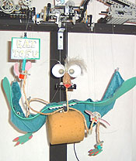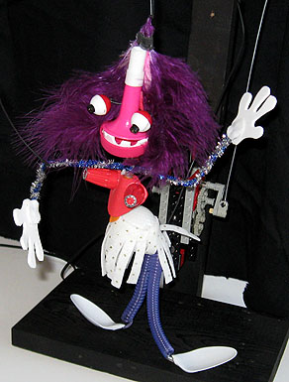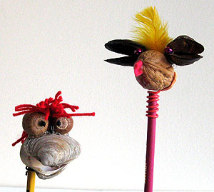

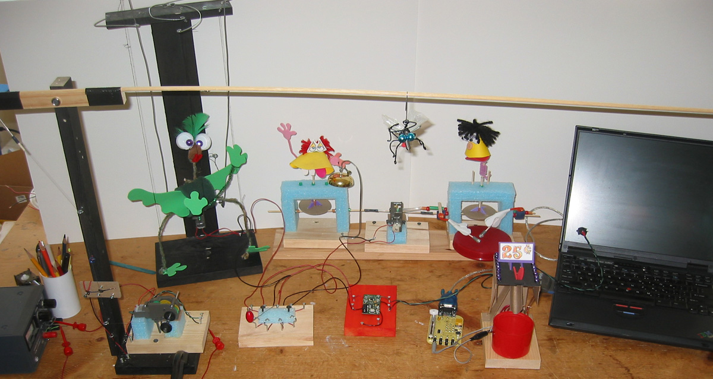

Rube Goldberg Candy Machine

Rube Goldberg was an inventor artist who dreamed of incredibly clever machines to solve very important problems. We could sure use a few more like him today, ‘cause we’ve got a major problem . . . the world needs more candy!

Your mission is to work in teams to design and build the ultimate CDD - Candy Delivery Device. A quarter will put the whole contraption into motion. One team's link will hand off its load of candy to the next team's link and so on, until finally the tasty payload is catapulted to the customer.

You can earn a ton of money and get a monumental belly-ache from all the candy you can eat!

Need some inspiration? Check out some amazing Rube Goldberg machines in action on YouTube.

This Mission includes:
Art | Construction | Presentation | Tasty Treats

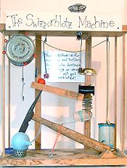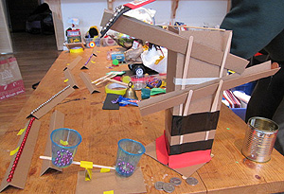

http://www.build-it-yourself.com/biy-projects/proj-rube-goldberg/index-chain.html

Robots That Earn Money

Build-It-Yourself is looking for some hot shot inventors to fix the global economy. Huge deficits, high unemployment and looming inflation have everyone down in the dumps.

Your mission is to build robots that create value, entertain, offer a service, put people to work, and pay their inventors handsomely. One young Build-It-Yourself engineer and his robotic sidekick raked in $27.25 in one day!

Combining LEGO Robotics systems, some premium quality junk, a dash of artistic flair and a bank-vault load of entrepreneurial imagination and spirit will drive your cash flow into positive territory and put your P&L solidly in the black.

Bill Gates ... the next generation of builders will soon be ready to carry your torch!

This Mission includes:
Art | Construction | LEGO Robotics | Imagineering | Presentation | High Finance

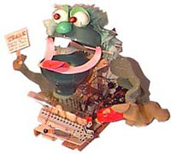

www.build-it-yourself.com/biy-projects/proj-money-makers/index-money-makers.html

Remote Control Pirate Ships

The Lure of Pirates' Cove

Shiver me timbers! Build-It-Yourself is conscripting a crew of scallywags and seadogs to build a fleet of pirate ships that will search the seas for fat cats who have too much gold, jewels and high yield treasury bonds. "Avast ya bloody, nat brain, pigeon gut, lying, double talking weasels! Yer money or yer life."

Mates will use research, imagination and premium quality junk to design and rig menacing (or cunningly inviting) model pirate ships and crews. The privateers will be powered by a remote control hull and navigate around a treacherous Pirates' Cove, staging epic sea battles and dramatic escapes. Arrgh!

This Mission includes:
Art | Construction | Modeling | Imagineering | Presentation | Swashbuckling and Deck Swabbing

Project site:
http://www.build-it-yourself.com/biy-projects/proj-pirates/index-pirate.html

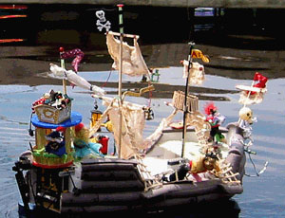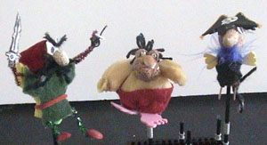

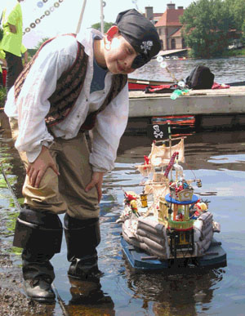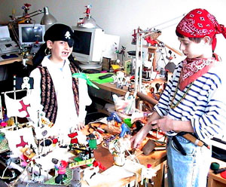
Flying Machines
Since the beginning of time, humans have dreamed about cruising the clouds like the birds and getting from one place to another faster than anyone else. A couple bros named Orville and Wilbur got us started around a century ago with one of the coolest contraptions ever, but there’s always room for improvement.

We’re recruiting a few smart cookies to join an advanced aerospace development team. You’ll start your training constructing state-of-the-art paper airplanes, then apply your new-found aerodynamics knowledge to the design of a supersonic glider. Then, it’s on to the next frontier, building and launching your own air-powered rocket in a 21st century “space race”. Finally, let your imagination soar as you turn premium quality junk into your own vision of the quintessential spacecraft of the future.

This Mission includes:
Art | Construction | Modeling | Presentation | The Wild Blue Yonder

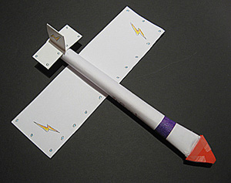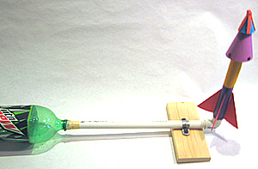

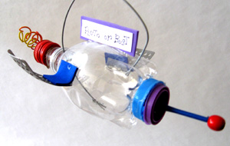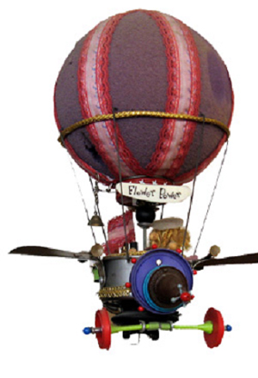

3D Graphics

Too bad Chris Columbus didn’t have a 3D artist on his crew when he was trying to convince all those European monarch types that the world isn’t flat. Chris had a reputation as a “deep” thinker, but frankly his PowerPoint charts had no depth. If they did, he may have picked up another ship or two and departed Spain a few years earlier with the Nina, the Pinta, the Santa Maria, and perhaps the Dora and the Diego.
21st Century explorers (not to mention game designers and animators) will need to be much more multi-dimensional than their 15th Century counterparts. 3D presentations will be required if they want to get funding for their missions to new worlds and exotic vacation resorts. Using state-of-the-art tools like Blender 3D, recruits for this 3D Graphics mission will create a video of a far out 3D spaceship that can navigate through a phantasmagorical galactic terrain. Remember, FLAT isn’t where it’s AT . . . go 3D!

This Mission includes:
Art | Modeling | Presentation | The Recently Discovered Z Axis

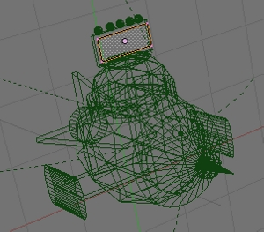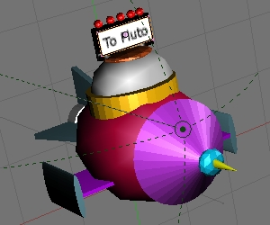

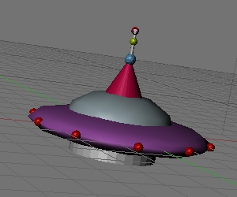
Website Design

Homepage Sweet Homepage.

Got something important to say? Want to show off your latest invention, computer game or video? Like to sell a gazillion gizmos? Trying to keep the rest of your Super Hero buddies up to speed on your plans to foil Dr. Disaster’s diabolical deeds?

You need to build your own website, and we’ll help you get started.

Find out just how the internet works and master all the web-speak you’ll need to collaborate with fellow web designers. Learn a new language – HTML – and a bunch of cool programming tricks that let you talk to all your favorite web browsers. Pick up tips for adding navigation links, graphics, photos, audio and video to the personal website you’ll design and build. Introduce your pets, tell some jokes, write a story, list your favorite computer games, music, movies, sports teams, super heroes. Finally, prepare for your site launch party, where you’ll present and take your site live for your family, friends and a few billion web surfers.

Crank up the bandwidth. We’re going viral and the hits will just keep on coming!

This Mission includes:
Art | Creative Writing | Programming | Presentation | Dot Com Bubbles



Soap Box Racer

Dirty gas guzzlers are fouling up our good air, using up barrels and barrels of expensive refined crude and hogging all the good parking places. Unsafe drivers are too busy texting to pay attention to the road and keep both mitts on the wheel. Back seat passengers are too involved watching DVDs to take notice of all the cool views and interesting places passing by. And the traffic . . . what about all the traffic!

We desperately need some new ideas to put the fun back in driving. Your mission: design and build a clean air, high MPG, nimble and speedy subcompact. A convertible would be nice. And cup holders . . . gotta have cupholders!

Teamwork plays a big role in this Mission. You’ll partner up with a small crew of fledgling automotive engineers to assemble and tune up a smooth-rolling and quick-swerving chassis. Then you’ll repurpose some premium quality junk to soup up your customized ride and draw in the fans. ‘Cause you must be fast and you must look cool when you and your pit crew take the green flag at the BIY Grand Prix. Let’s hit the road!

This Mission includes:
Art | Construction | Presentation | Breakneck Speed

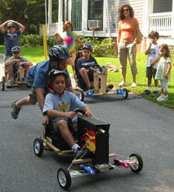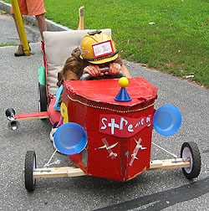

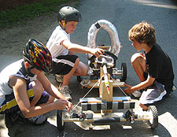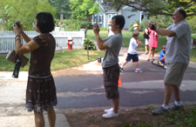
Computer Graphics and Animation

Besides a strong dislike of brussels sprouts, what did DaVinci, Van Gogh and Picasso have in common? Right. None of them had a computer. Just imagine what Leo could’ve done with a laptop, Vincent with vectors, Pablo with pixels.
Generations are often judged by the art they leave for their descendants. If we want to be recognized as a hot shot civilization, we need to get our creative juices flowing and take advantage of the fantastic new artistic tools that those great masters couldn’t even dream of.

Your mission is to design digital artifacts that will make future civilizations say, “Wow!” .

Learn from experienced designers & programmers how to design animated cartoons and far out graffiti, create cool screen savers, illustrate a storyline, and develop graphics for a Web site. You will learn to use both vector and pixel-based drawing tools – primarily PowerPoint and Gimp.

This Mission includes:
Art | Programming | Presentation | Artistic License

www.build-it-yourself.com/biy-projects/proj-media-design/index-graphic-design.html

Scratch Games

Are you a hotshot gamer? How cool would it be to become a crackerjack game designer? If you think you’ve got the talent, let us show you the tools you need to get started.

Playing games, especially multi-player teamwork games, can help you develop a valuable set of collaboration, critical thinking and decision-making skills – skills you’ll need to be a “player” in today’s high-tech world. Besides that, they’re challenging and fun!

Building games gives you all that and more.

Use PowerPoint to develop a storyline and design graphics for rocket ships, friendly dragons, super heroes, evil doers and other wacky characters. Lay out fantasy settings and scenes in Gimp. Record and edit outrageous sound effects. Learn to use Scratch programming to put it all together. Then test out your game with your friends and post it on the Web for the world to play.

Dig deep . . . you may develop the next Minecraft. Mom and dad will love the new iPads you’ll buy them!

This Mission includes:
Art | Programming | Presentation | Thumbnastics

c
c
c
Build-It-Yourself
Launch Pad

Scratch Animated Cartoons

We’ve got a big problem. Our planet is running low on some very important commodities, and whole countries are getting up in arms and starting nasty and costly brouhahas all over the globe. It’s been the same story for ages. Greedy, combative politicos have started wars over such treasures as tea, spices, gold, silver and beaver pelts . . . not to mention cotton, water, mineral rights, crude oil, candy and beachfront property. But today’s commodity shortage can only be solved by some cool and creative guys and gals.

The latest dilemma? We’re running out of laughs. You know. Chuckles. Guffaws. Giggles. Snickers. Yep, a hearty har-de-har-har is getting har-de-har-harder to find.

The good news? Laughter is a renewable resource. Any kid can tell you how to replenish the supply so there’s enough to go around for everyone.. It’s simple. Just crank out more cartoons and comic strips.

That’s where you come in. We’re enlisting a corps of raw recruits for some basic training in a few drawing and animation tools and techniques. You’ll start with the most effective tool in your arsenal – your imagination – to create a storyline that will have ‘em rolling in the aisles. Next you’ll use the great drawing tools in PowerPoint to create characters, scenes and props. Then it’s on to a little Scratch programming, to animate and add audio and specials effects to your production. Finally, you’ll release your masterpiece on the Web, garnering such international acclaim and so many smiles that there’s a good chance you’ll be nominated for the Nobel Peace Prize (to go along with your Oscar for Animated Shorts).

This Mission includes:
Art | Creative Writing | Programming | Presentation | Whams, Pows and Kabooms

Time Machines

Do you have trouble waking up in the morning? Are you setting new records for hitting the snooze button on your alarm? Are you constantly late for board of directors meetings for the multinational game design company you and your buddies formed last month?

What you need is a 21st Century Time Machine. A personalized chronometer that doesn’t just keep time, but cheerfully shares it with anyone in the general vicinity. A customized extreme cuckoo clock that starts the day and wakes you up in a civilized, but guaranteed way. It could tickle you, play some tunes, spray you with water, beat a drum, tell a joke, prep you for a pop quiz, launch the latest You Tube meme or pitch a fistful of M&Ms at your sleepy head. Once it wakes you up it can continue its mission throughout the day by making a critter you design come to life every hour, on the hour - keeping your parents on their game and repeatedly annoying the cat.

This is a cool, multi-discipline project involving both physical and virtual building. Repurpose some premium quality junk to design and construct friendly timekeeping varmints and their stages. Incorporate some basic LEGO robotics to make them shake, rattle and roll. Use the Scratch programming platform to keep the time, drive the motors and add some audio, or go totally digital by creating custom computer graphics and designing and animating a virtual timepiece.

This mission will challenge your creativity and sharpen your skills. We'll bring the tools, you bring the talent. And oh yeah . . .have you got the time?

This Mission includes:
Art | Construction | Programming | LEGO Robotics | Presentation | Ticks | Tocks

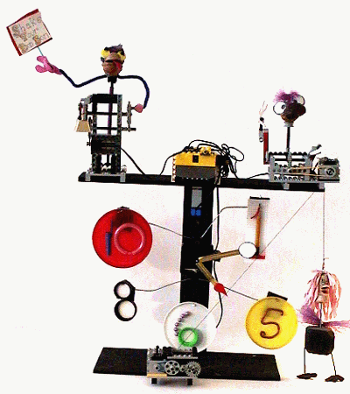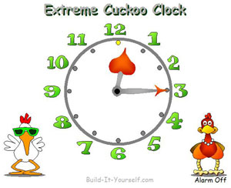

LEGO Super Hero Robots

Superman and Lois Lane are on the rocks. Batman is down in the dumps and can’t decide on a name. Dick Grayson has retired his Robin gig and there are slim pickin’s in the sidekick replacement pool. Wonder Woman is contemplating chucking it all for a political career. And every one of them has costume issues. Meanwhile, the bad guys just seem to be getting more dastardly, dishonest, despicable and diabolical by the doggone day.

It’s just getting harder and harder to count on the old-school carbon-based super heroes to get the job done defending Truth, Justice and The American Way.

It may be time to start putting our support behind a new generation of robotic super heroes. We need a crack crew of engineers to hit the lab and start designing, assembling, testing and deploying a new class of mega-powered programmable guardians to step into the void.

Using LEGO Robotics components you’ll collaborate with a small design team to develop, build and program a controllable super hero prototype that will be put to the test at the Build-It-Yourself Super Hero Performance Evaluation Center.

You’ll go head-to-head against competing designs in contests of speed, strength and power. Your brainchild will race, climb and launch sugar-based edible projectiles in an effort to make also-rans of the competition and build an adoring fan base. Because costumes are absolutely critical to a super hero’s popularity and effectiveness, you’ll need to jazz up your collection of blocks, gears and wheels with some suitable fashion accessories. Finally, you’ll present your ideas, solutions and the latest and greatest super hero to a grateful public. And collect sidekick applications.

This Mission includes:
Art | Construction | Programming | LEGO Robotics | Presentation | Secret Identities

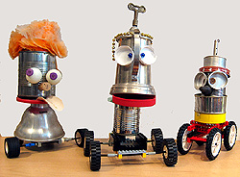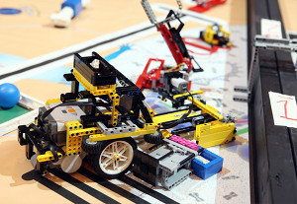

Digital Music Video

Overview:
Are you tired of bland, boring, repetitive music? Would you rather create something new, groundbreaking, far out that rings your bells, tickles your fancy, flips your jacks?
Today, with the invention of music mixing software, mash-up music is IN!
We will use Scratch and Audacity to create your own mash-up music video that will become the next number one hit on the billboard charts.

The Problem:
Many people are mad, unhappy and in a funk about life and the world around them.
Your Mission:
Make people wanna dance and get together by composing 'knock-your-socks-off' music!

This Mission includes:
Art | Creative Writing | Music Theory | Programming | Presentation | Foot stomping

Remote Control Fruit Critter Goblins
Overview:
Did your mom ever tell you not to play with your food? You'll need a good collection of funny-looking fruits and veggies, acorns, sea shells, craft supplies and premium quality junk. Then you'll need to dream up some jokes and cartoon story lines. Finally, you've got to make your critter come to life and act out your storyline using a remote control device!

Progress is often the result of thinking beyond what most folks think. For example, if we thought fruits and vegetables were only for eating, we never would have invented powerful medicines, beautiful musical instruments, efficient lubricants and the all- important food fight!

The Problem:
The world needs more creative thinkers to fix the messes past generations have left us.

Your Mission:
Your mission is to find new ways of using funny-looking fruits and veggies that will make people laugh and think.

Think outside the box!

This Mission includes:
Creative Writing | Art and 3D Sculpting Theory | Presentation | Discipline to Resist a Food Fight
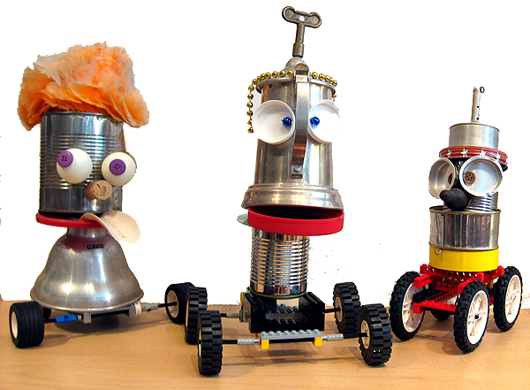

Set up your Laboratory / Robotic Door Greeters
To be a proper Build-It-Yourself crew member, you'll need to have a state-of-the-art laboratory ... a set of tools, parts, premium quality junk, and a proper shingle for your door. You should have an official brainstorm hat, a smart pencil and a lab book to document your inventions.
And most importantly, you'll need a robotic door greeter.

If you want to be a hot shot engineer, you need to look like one!

Your mission is to make visitors to your home laboratory say, "WOW, an awesome builder works here! I want to be a member of the Build-It-Yourself Crew."

This Mission includes:
Art | Creative Construction | Presentation | Thinking outside the box

Set up your Laboratory / Robotic Door Greeters

So you wanna be a builder? That's cool!
Before you get started, you're going to need a special place . . .
A place to get inspired.
A place to think up some out-of-the-box ideas.
A place to keep your stuff (especially your Premium Quality Junk).
A place to store and use your tools.
A place to hang with fellow builders.
A place where the bad guys, super villains and Ludites (Google it) can't bother you.

Yep . . . you're gonna need a LAB! And we're gonna help you build it.
New Build-It-Yourself Rookie Builders will start off by stamping your own sense of style on your building "digs" by designing and crafting a smart pencil and creating a unique lab door shingle. You'll learn all the tricks of recognizing and collecting useful "Premium Quality Junk.” You'll fashion a one-of-a-kind Brainstorming Hat to help get your creative juices flowing and perhaps launch the next trend in headgear. Finally, you'll build a special door greeter to welcome your buddies and keep the riff-raff out.

Throughout the process you'll be developing your PowerPoint skills by keeping a PowerPoint Lab Book to document your cleverness and creativity and present your results - handy skills that you'll use over and over on future building missions.

So what are we waiting for? Let's get building!

This Mission includes:
Art | Construction | Presentation | Bodacious Bonnets

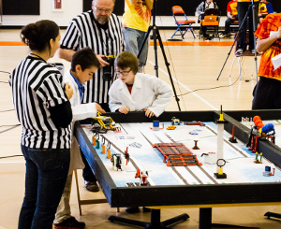

First LEGO League (FLL) Coaching
First LEGO League (FLL) is a popular, world-wide robotics competition. 160,000 kids registered in 2012.

Build-It-Yourself engineers coach teams to:
- Build a competitive, autonomous robot that can accomplish multiple FLL challenges.
- Research and present how technology can solve a specific problem in society.
- Practice FLL 'Core Values'

This Mission includes:
Research skills | Strategic thinking | Modular construction techniques | Programming skills | Teamwork | Presentation skills

