You can’t judge a dragon by its scales!

The Problem:
The world is burdened with wars that are often the result of illogical prejudice. Imagine you are a dragon that wants to live in peace. But everyone is trying to slay you just because you look like a dragon. Of course you'd be mean!

If we want to live in a land free of meanness, this cycle of prejudice and counter-prejudice must be stopped.

Your mission:
Figure out what a dragon must do to win a friend. Then you must build and present that dragon. You must program your dragon to offer a friendly greeting when it detects another life form.

At the end of this mission, all the dragons will attend a “Noble” Peace Party.

Guidelines and solutions for this mission are posted at:
http://www.build-it-yourself.com/mission/mission2.htm

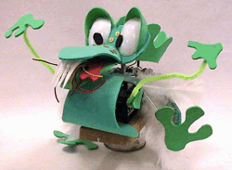

Questions to discuss:

1) The Problem:
- What's the definition of prejudice?
- What are examples of prejudices?
- What causes prejudices to form?
- What prejudices do you have?
- Why can prejudices be bad?
- Could prejudices ever be good?

2) The Solution:
- What can one do to eliminate a prejudice?
- What can the subject of a prejudice do to help eliminate a prejudice?
- What friendly gestures could be simulated by a robot?

Lab Session #1:
Presentations
- Define the problem.
- Define guidelines for a solution.
- Discuss possible solutions

Action
- Design and build parts of your solution. (Eyes, mouth, wings, feet, tail, signs)
http://www.build-it-yourself.com/mission/mission-cuckoos.htm
- Clean up
- Report progress.

Documentation suggestions (between classes)
- Collect junk for your robot:
http://18.85.1.70/moduleDetail.asp?moduleID=19
- Draw a small, colorful sign with a slogan on it using your best graffiti. “War is not the best answer.” “Eat Tofu” “Flower Power” “???” Use a business card.
- Write a poem, song or short story on any of the prejudice questions posed in class.

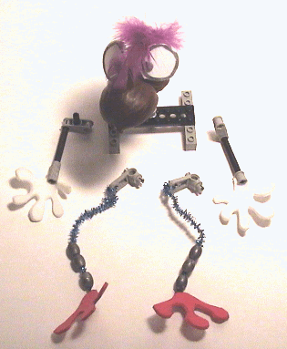 | If you keep the sections of your solutions separate (i.e. not glue them together) then:  - you will have more flexibility to make the sections of your solution work independently.  - You will be able to edit or change your solution sections more easily.



Faces



Body Parts
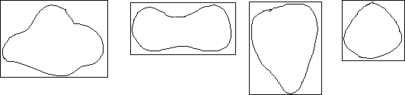

Flappers or Wings
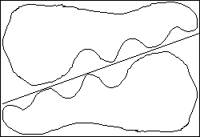

Lab Session #2:
Presentation (15 minutes)
- Review the problem, goals and guidelines.
- Discuss strategies for solving a complex problem.
- Introduce the library of Build-It-Blocks.
http://www.build-it-yourself.com/build-it-blocks/
- Discuss leverage and speed vs. torque trade-offs.
http://18.85.1.70/stepDetail.asp?stepNumber=9&moduleID=67

Action (50 minutes)
- Attach dragon parts to small LEGO pieces that can then snap onto mechanical motion modules. This allows you to change your solutions quickly and to share motion modules.
- Integrate, test and edit your constructions.
- Clean up.
- Present progress.

Documentation suggestions (between classes)
- Document the strategy to build your solution.
- Document how Build-It-Blocks can help you build complex solutions.
- Why are gear trains useful?
http://18.85.1.70/stepDetail.asp?stepNumber=9&moduleID=67
- What are advantages of gears vs. pulleys?
http://18.85.1.70/stepDetail.asp?stepNumber=8&moduleID=67
- Draw a small, colorful sign with a slogan on it using your best graffiti. “War is not the best answer.” “Eat Tofu” “Flower Power” “???” Use a business card.
- Write a poem, song or short story on any of the prejudice questions posed in class.

To learn more about leverage and gears, download the Rabbit vs. the Turtle Physics of Gears. (For Windows machines only.)
http://18.85.1.70/stepDetail.asp?stepNumber=11&moduleID=67

Lab Session #3:
Presentation (10 minutes)
- Review the problem, goals and guidelines.
- Discuss how flow charts can help you understand the logic of a control program.

Action: (40 minutes)
- Program your solution to execute when an event is detected.
- Integrate, test and edit your solutions.
- Clean up.
- Present progress

Documentation suggestions (between classes)
- Why is a flow chart useful?
http://18.85.1.70/moduleDetail.asp?moduleID=54
- Outline and practice a presentation for a school assembly.
- Write and illustrate a story, poem or song that clearly describes your solution. Use rhymes, analogies, similies and logic to describe your solution.
http://18.85.1.70/moduleDetail.asp?moduleID=79
http://18.85.1.70/moduleDetail.asp?moduleID=71

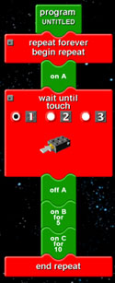
Lab Session #4:
Test and edit solutions

Present solutions on a Web page or in a Power Point presentation

Present and critique solutions with the class.

Questions / Worksheets (You can’t judge a dragon by its scales!)

1) The Problem: (Write a 1-page essay about any of these issues)
- What's the definition of prejudice?
- What are examples of prejudices?
- What causes prejudices to form?
- What prejudices do you have?
- Why can prejudices be bad?
- Could prejudices ever be good?

2) The Solution: (Write a 1-page essay about any of these issues)
- What can one do to eliminate a prejudice?
- What can the subject of a prejudice do to help eliminate a prejudice?
- What friendly jesters could be simulated by a robot?

